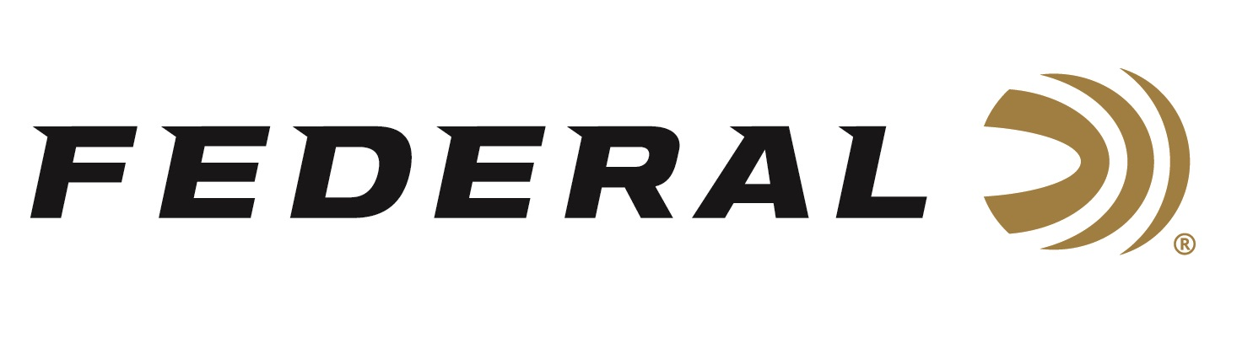

FOR IMMEDIATE RELEASE

A Firearms History Lesson on “It’s Federal Season” Podcast

ANOKA, Minnesota – March 17, 2022 – Federal’s “It’s Federal Season” podcast will have a new format in 2022. Utilizing the brand’s talented ambassadors, a series of guest hosts will entertain and inform on numerous topics where they have expertise as well as interview great guests.

The first guest host is Julie Golob. “Julie is one of Federal’s most respected ambassadors,” said Brian Anderson, Federal’s Marketing Director. “As a professional shooter, she is champion in many disciplines but as important as that is, she is a great role model for all shooters and we are excited to have her lead off the new podcast format.”

Golob’s first guest is Ashley Hlebinsky from The Gun Code. Ashley is one of the nation's foremost authorities on firearms history and over the past decade, she has worked in and managed some of the largest firearms collections and museums in the world.

Both Golob and Hlebinsky are experts in their fields and discuss a variety of topics including Women’s History Month relating to firearms, their favorite firearms, and historical collections. A great episode for historical perspectives.

Episode #31 “A Firearms History Lesson”
https://www.federalpremium.com/this-is-federal/podcast/

For this episode, besides listening on the Federal Premium website or Talk North podcast network, you can also subscribe to Federal Ammunition’s YouTube channel (https://www.youtube.com/user/federalpremiumammo) and tune in for the discussion.

Federal Ammunition can be found at dealers nationwide or purchased online direct from Federal. For more information on all products from Federal or to shop online, visit www.federalpremium.com.

Press Release Contact: JJ Reich
Senior Manager – Press Relations
E-mail: VistaPressroom@VistaOutdoor.com

About Federal Ammunition
Federal, headquartered in Anoka, MN, is a brand of Vista Outdoor Inc., an outdoor sports and recreation company. From humble beginnings nestled among the lakes and woods of Minnesota, Federal Ammunition has evolved into one of the world's largest producers of sporting ammunition. Beginning in 1922, founding president, Charles L. Horn, paved the way for our success. Today, Federal carries on Horn's vision for quality products and service with the next generation of outdoorsmen and women. We maintain our position as experts in the science of ammunition production. Every day we manufacture products to enhance our customers' shooting experience while partnering with the conservation organizations that protect and support our outdoor heritage. We offer thousands of options in our Federal Premium and Federal® lines-it's what makes us the most complete ammunition company in the business and provides our customers with a choice no matter their pursuit.

